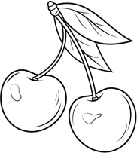
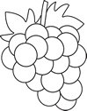
Horticulture Dept.

General Rules
- Entries will be accepted Tuesday, 4:00 PM – 7:00 PM and Wednesday, 7:30 AM – 9:30 AM. They will be released after 5:00 PM on Saturday.
- With permission, fruits and vegetables may be sold at the baked goods auction on Wednesday.
- Senior Classes – A Blue, Red, and White ribbon will be awarded in each section. A Best of Show Rosette along with a $5.00 cash prize and Honorable Mention Rosette will be awarded per division.
Junior Classes – A Blue, Red, and White ribbon will be awarded upon merit of the judges. Each entry will receive a ribbon. A Best of Show Rosette along with a $5.00 cash prize and Honorable Mention Rosette will be awarded per division.
- Junior Division – (Exhibitors age 18 and under) Age must be listed on entry tag. A “J” will be added to indicate a Junior Exhibitor.
- People panning to exhibit vegetables are urged to get Guide Sheet #6230 – “Exhibiting and Judging Garden Vegetables” from their local Extension Center (Monticello). Please prepare the exhibit as outlined in the guide.
- Exhibits should be displayed in appropriate container for viewing (cardboard boxes not allowed).
- Fair and show committees will exercise all care but cannot be held responsible for damage or loss of items exhibited.

Division – Vegetables
Section 1 – Broccoli
2– Dry Yellow Onions (6)
  - – Dry White Onions (6)
  - – Dry Red Onions (6)
  - – Tomatoes (4)
  - – Pumpkin (1)
  - – Summer Squash (2)
  - – Winter Squash (1)
  - – Slicing Cucumbers (4)
  - – Pickling Cucumber, green (6)
  - – Eggplant (2)
  - – White Potatoes (6)
  - – Sweet Potatoes (4)
  - – Red Potatoes (6)
  - – Peppers (5) 16 – Hot Peppers
17 – Sweet Corn (6 in husks) 18 – Carrots, cut tops (5)
- – Cabbage, flat (1)
- – Cabbage, round (1)
- – Beets, tops trimmed (6)
- – Cauliflower
- – Green Beans (8)
Section 24 - Wax Beans (8)
- - Garlic (6)
- - Miscellaneous Vegetable

Division – Fruits
Section 1 – Plate of Grapes (3 bunches) 2 - Plate of Red Apples (5)
3 – Plate of Yellow Apples (5) 4 – Berries (50 berries in bowl) 5 – Plate of Peaches (5)
- – Rhubarb (4)
- – Watermelon (1)
- – Cantaloupe (2)
- – Collection of fruit
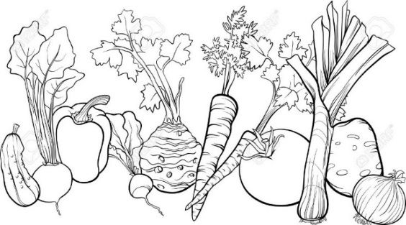
*tray with 2+ kinds of fruit 10 – Miscellaneous Fruit

