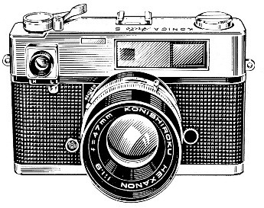
Photography Dept.

General Rules
- Entries will be accepted Tuesday, 4:00 PM – 7:00 PM and Wednesday, 7:30 AM – 9:30 AM. They will be released after 5:00 PM on Saturday.
- Each exhibitor may have no more than five total entries.
- Entries are divided by size, as follows:
Snapshots include all pictures 4”x6” or smaller.
Photographs include all pictures at least 5”x7” but not larger than 16”x20”.
- It is strongly suggested that all entries be matted or framed. This assists with photo presentation for judging and viewing.
- Entries will be judged on photo quality, composition, and artistic merit.
- Photographs must have been taken within the preceding twelve months.
- Senior Classes – A Blue, Red, and White ribbon will be awarded in each section. A Best of Show Rosette along with a $5.00 cash prize and Honorable Mention Rosette will be awarded per division.
Junior Classes – A Blue, Red, and White ribbon will be awarded upon merit of the judges. Each entry will receive a ribbon. A Best of Show Rosette along with a $5.00 cash prize and Honorable Mention Rosette will be awarded per division.
- Junior Division – (Exhibitors under the age of 18) Age must be listed on entry tag. A “J” will be added to indicate a Junior Exhibitor.
- Professionals, teachers, or photography club members are NOT eligible for prize money – rosettes and ribbons only.
- Fair and show committees will exercise all care but cannot be held responsible for damage or loss of items exhibited.

Division:

Color Snapshots:
Section 1: Flowers
2: Landscape
3: People
4: Animals
5: Architecture
6: Vehicles (including farm equipment)

Color Photographs:
Section 1: Flowers
2: Landscape
3: People
4: Animals
5: Architecture
6: Vehicles (including farm equipment)

Black and White Snapshots:
Section 1: Flowers
2: Landscape
3: People
4: Animals
5: Architecture
6: Vehicles (including farm equipment)

Black and White Photographs:
Section 1: Flowers
2: Landscape
3: People
4: Animals
5: Architecture
6: Vehicles (including farm equipment)

Collages (Two or more photographs or snapshots matted or framed together; an entire collage may still not be larger than 16”x20”)
Computer Enhanced (Photographs and snapshots in this class will be judged together)

