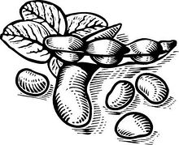
Field Crops Dept.

General Rules
- Entries will be accepted Tuesday, 4:00 PM – 7:00 PM and Wednesday, 7:30 AM – 9:30 AM. They will be released after 5:00 PM on Saturday.
- ALL exhibits must have been produced this year.
- All rooted entries must be in dirt and waterproof containers.
- Senior Classes – A Blue, Red, and White ribbon will be awarded in each section. A Best of Show Rosette along with a $5.00 cash prize and Honorable Mention Rosette will be awarded per division.
Junior Classes – A Blue, Red, and White ribbon will be awarded upon merit of the judges. Each entry will receive a ribbon. A Best of Show Rosette along with a $5.00 cash prize and Honorable Mention Rosette will be awarded per division.
- Junior Class – (Exhibitors age 18 and under) Age must be listed on entry tag. A “J” will be added to indicate a Junior Exhibitor.
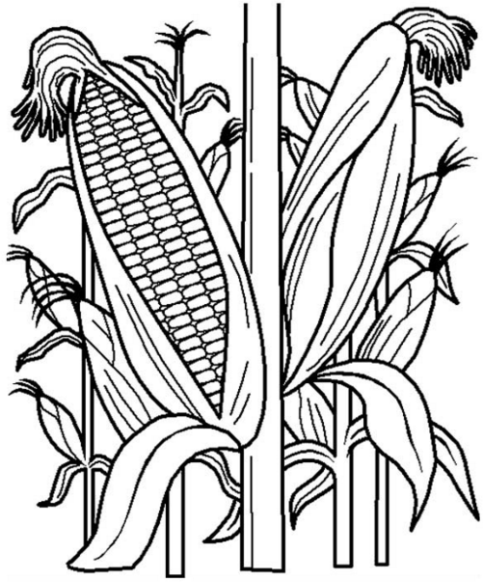
- Fair and show committees will exercise all care but cannot be held responsible for damage or loss of items exhibited.

Division: Corn
Section 1: Corn plant with root system
2: One gallon shelled corn (2016 crop) 3: Ear Corn

Division: Beans
Section 1: Six bean plants with roots in same container 2: One gallon soybeans (previous year crop)

Division: Wheat
Section 1: One gallon wheat (previous year crop)

Division: Hay
Section 1: One 4” flake or block of hay

Division: miscellaneous
Section 1: Any crops not listed above

